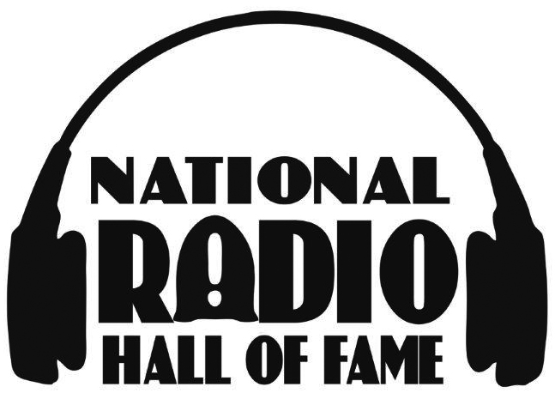
EMBARGOED UNTIL MIDNIGHT ET

Press Contact:
Amir Forester, 310.967.9905
amir@foresterpublicrelations.com

National Radio Hall of Fame Announces 2016 Class of Inductees

Induction Ceremony Tickets on Sale Now at Radiohof.org

LOS ANGELES, July 11, 2016 – Voting results for the 2016 National Radio Hall of Fame’s 24 nominations in six categories are in. Four of those categories were decided by a voting participant panel comprised of 400 industry professionals. The other two categories, Music Format On-Air Personality and Spoken Word On-Air Personality, were voted on by the public. The 2016 inductees are:
Eric & Kathy (Eric Ferguson & Kathy Hart), WTMX 101.9fm The Mix Chicago
Active Local/Regional, 10+ years

Jeff & Jer (Jeff Detrow & Jerry Cesak), KyXy 96.5 FM San Diego
Longstanding Local/Regional, 20+ years

Steve Harvey, The Steve Harvey Morning Show; syndicated by Premiere Networks
Active Network/Syndication, 10+ years

Delilah, syndicated by Premiere Networks
Longstanding Network/Syndication, 20+ years

Bob Kingsley, Bob Kingsley’s Country Top 40; syndicated by Westwood One
Music Format On-Air Personality

Michael Savage, The Savage Nation; syndicated by Westwood One
Spoken Word On-Air Personality

Additionally, the National Radio Hall of Fame nominating committee voted to induct four individuals for their contribution to the industry. Those inductees are:
George G. Beasley, Chairman/CEO/Founder of Beasley Broadcast Group, Inc.
Kidd Kraddick, the late beloved national air personality and founder of Kidd’s Kids Charity
Tony Roberts, former sportscaster and play-by-play announcer for Notre Dame Football
Neil Rogers, the late legendary southern Florida air personality

-more-

2016 NRHOF Inductees
Page 2

National Radio Hall of Fame Chairman Kraig T. Kitchin comments, “This year’s class of inductees represents the diversity that makes radio so personal, entertaining and impactful. We all very much appreciate everyone who participated in this process as we welcome the very best in our business into the National Radio Hall of Fame.”
The black-tie optional induction ceremony takes place at the home of the National Radio Hall of Fame – the Museum of Broadcast Communications in downtown Chicago from
6-9 p.m. on Nov. 17. Tickets are now available at www.radiohof.org. A portion of ticket purchases is a tax deductible charitable donation to the Museum.

About the National Radio Hall of Fame and Museum of Broadcast Communications
The institution collects, preserves, and presents historic and contemporary radio and television content as well as educates, informs, and entertains the public through its archives, public programs, screenings, exhibits, publications and online access to its resources. The museum is located at 360 North State Street in downtown Chicago and was founded in 1983 by veteran broadcaster Bruce DuMont.

# # #

